MindOut  LGBTQ Mental Health Service  Rainbow Fund Grant Report  1st April 2016 to 31st March 2017 | 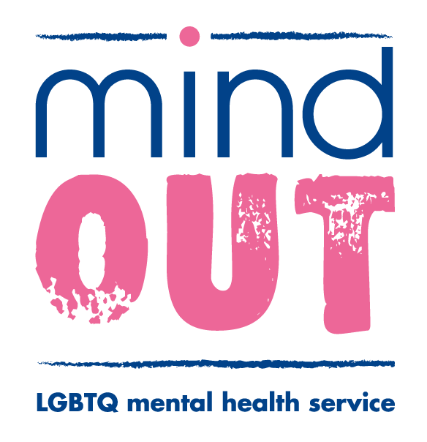

80% of group members reported significant reduction
in the frequency and intensity of suicidal thoughts and
60% reported significant improvements to self-injury.

“Peer support is lifesaving. MindOut services are lifesaving! I’m still suicidal, I’m not out of the woods, but with the support from my group (Out of the Blue) I am getting there. I have hope!”

MindOut’s peer support group work service has continued to generate high levels of interest and demand this year, with an increase in people requesting an appointment for a group work assessment. Our groups have been oversubscribed and once again we have had to administer waiting lists for all new and upcoming groups.

Peer support groups that we have run this year have included a weekly drop in and social group, which holds a consistent membership of 40 people and 4 weekly closed peer support groups which are either subject or identity themed, with a maximum of 9 members per group. Our closed groups follow a rolling timetable which is based on interest and demand, group themes have included; Out of the Blue (for people with experience of suicidal distress), Work it Out (for people concerned about their mental health and are in paid employment) a non binary group, an under 30’s group and an over 50’s group, groups for LGBTQ women and GBTQ men and an LGBTQ BAME group. All of MindOut groups are facilitated by experienced LGBTQ group workers with lived experience of mental health issues.

This year The Rainbow Fund has supported ‘Out of the Blue’, our peer support group for people living with suicidal thoughts, or who have lived experience of suicidal distress. Out of the Blue continues to provide an opportunity for people to share their thoughts and experiences about suicide with others in a safe and supportive space without judgement or feelings of guilt, fear or shame.

Over the last 12 months, Out of the Blue has run for 44 weeks
with a membership of 19 people who have attended 232 times,
averaging 12 attendances per person.

“ I’ve struggled to stay alive all of my adult life, my suicidal thoughts are constant... I have been continually misunderstood by mental health professionals… pathologised, judged, and abused because of my non-conforming gender identity. MindOut services are the only support I have ever had. I would be dead today without MindOut”

Out of the Blue members have received and offered peer support on many issues this year, including: distress and intrusive thoughts about suicide, coping strategies, self-care, self-harm, relationship issues, loneliness and isolation, anxiety, loss and bereavement, childhood trauma, sexual violence, rape, managing stress, medication and treatment, trans issues and care pathways, community safety, depression, living with exhaustion, sleep related issues and insomnia, bullying, transphobia, work and employment, self-esteem, self-confidence, parenting, getting older, death, body dysmorphia, sexuality and sexual orientation, living with HIV, sexism, gender issues, non-binary identities.

“ I didn’t think the group would be helpful to be honest, but I was so wrong. I have never spoken about my desire to kill myself before; I thought people would consider me selfish, a horrible human being. I found the courage to talk and in turn I found support and friendship”

Impact and Evaluation

At the beginning and at the end of each 9 week block members are asked to complete wellbeing scales, which allow us to monitor and compare changes or improvements experienced by individual group members as a direct result of being part of the group. Group members are also asked to fill out anonymous evaluation forms at the end of their membership.

This year group members reported consistent improvements in their wellbeing, the most significant have been:

- reduced suicidal distress
- improved sleep routines
- improved anger management
- reduced self injury
- reduced feelings of isolation
- feeling more informed and empowered

When asked to describe their experience of Out of the Blue, members told us:

- Top marks, the group keeps me safe
- Its useful to share and learn from experience
- Listened to, understood
- A place to develop confidence
- Less suicidal
- Supported, held, looked after

Access and Assessment

All new enquiries to MindOut about our group work service are offered an appointment to meet with a MindOut worker and complete a group work assessment. The appointment offers an opportunity for the person to talk about how they are feeling, why support peer might be helpful, whether they have experiences of suicidal thoughts and suicidal distress, their coping strategies and staying safe. At the appointment, information and resources are made available which include details of other services and support available at MindOut, for example: mental health advocacy, housing advocacy, trans specific advocacy and support, peer mentoring, wellbeing courses and workshops and our online support service.

Following a group work assessment we can usually offer places to new members in our weekly open and social groups immediately. We hold waiting lists for all of our themed closed groups and people are offered a place in the closed group of their choice, as and when one becomes available. When setting up new groups and offering places we follow an allocations procedure, prioritising people who are: new to the service; who are socially isolated; who have little or no mental health support or social support; and/or where there are safeguarding concerns.

“This group (Out of the Blue) has been a lifeline to me and many others, possibly hundreds of desperately isolated and distressed LGBT individuals. Funding for this group must never be at risk, it’s just too important”

