Community Base
113 Queens Road
Brighton
BN1 3XG

t: 01273 234839
e: info@mindout.org.uk

Company Number 7441667
Charity Number 1140098

August 2021

Dear Applicant,

Thank you for your interest in the Online Service Coordinator post with MindOut.
Enclosed with the application pack are:
- a job description
- a person specification
- background information about MindOut
- an application form
If you would like this information in another format, e.g. large print or in audio format please let us know.

The post is full time, ie 35 hours per week and is a permanent contract subject to on-going funding. The hours can be worked flexibly by arrangement and will involve occasional evenings and weekends. The post holder will be based in our office at Community Base, 113 Queens Road, Brighton with some regular home working, as necessary.

The salary for this post is £27,306 pa (FTE). MindOut provides up to 5% of salary contribution to our pension scheme, depending on employee contribution. The post holder is entitled to 29 days leave per year pro rata, excluding Bank Holidays, plus one day for your birthday.

Applications will be judged according to the criteria of the job description and person specification as required by our Equality, Diversity and Inclusion Policy and Recruitment Policy. Please make sure you answer every point in the person specification on your application form, paying attention to essential criteria. All successful applicants are subject to an enhanced DBS check. This post is subject to a probationary period of 6 months.

Support for the post holder will be through line management supervision with the MindOut CEO, participation in our externally facilitated management reflective practice sessions and access to our Employee Assistance Scheme.

Please return your application form to myself at the above address or via email to info@mindout.org.uk. I regret we are unable to accept late applications.
The closing date for applications is 5pm on Thursday 30th September and interviews will be held on Monday 4th October.

Yours sincerely,
Helen Jones
CEO

Online Service Coordinator

Job Description

Responsible to: Service Manager

Summary of Duties

- to coordinate, recruit, train and support a team of volunteers
- to coordinate and develop MindOut’s national LGBTQ online mental health support service
- to deliver out of hours, online support sessions throughout the week
- to promote the online service particularly through digital and social media

Main Tasks

Project related
- to coordinate, and supervise our team of online support volunteers, lead regular team meetings in person, in Brighton
- to run regular recruitment and training for new volunteers, in conjunction with the Peer Support Senior Practitioner
- to maintain and oversee the weekly volunteer rota
- to deliver regular, out of hours online support sessions including evenings weekends and bank holidays
- to publicise and promote the online service especially through social & digital media and in person
- to develop relationships with social networking websites and apps to promote services and improve access to support for their users
- to support the administration team to run MindOut’s twitter, Facebook, Linkedin and Instagram accounts, creating content, make sure these channels are up to date, and maintain a high level of engagement and audience growth
- to develop monitoring and evaluation tools for the service and to report on the webchat analytics
- to identify trends in access to the online service and in the issues raised by service users and plan developments accordingly
- to provide regular verbal and written reports as requested
- to work to agreed standards, recording, referral, monitoring and evaluation systems
- maintain strict confidentiality with regard to information given by and information about service users

General Responsibilities
- monitor, address and improve issues of general concern in the delivery and quality of the service
- to monitor, coordinate, record and report safeguarding responses and decision making
- liaise with statutory and voluntary sector service providers on issues which arise from the course of the work
- identify development and expansion opportunities
- provide information and advice on LGBTQ issues to other professionals, services , organisations
- provide outreach and promotion of the service and to support corporate outreach promotion
- maintain links with service user groups and other bodies as appropriate, to ensure that MindOut’s development remains centred on service users’ perceived needs
- to maintain awareness of LGBTQ mental health issues and developments on a national basis
- attend as appropriate meetings with the CEO, staff team and MindOut executive and sub committees
- prepare regular reports as required by the CEO, MindOut committees or the project funder
- carry out other such tasks as appropriate in negotiation with the CEO, which may be reasonably expected
- carry out all responsibilities with regard to MindOut’s Equality, Diversity and Anti-discrimination Policy and all other policies
- to participate in relevant training and self–development

This job description will be reviewed periodically with the post holder to take account of changing demands.

PERSON SPECIFICATION

Outlined below are the experience, skills, knowledge and competencies required to carry out the tasks described within the job description. Please ensure that you use examples to demonstrate that you meet each individual criterion on your application form. Criteria marked ‘A’ will be used to shortlist candidates and criteria marked ‘I’ will be assessed during the interview stage. Criteria marked E are Essential to the role, D are desirable for the role.

No. |  | Essential/  Desirable
 | Experience
1 | Personal lived experience of LGBTQ identities and understanding and broad experience of working with LGBTQ people and communities | E
2 | More than 6 months experience of working within the health and social care field. | E
3 | Experience and understanding of mental health issues. Personal experience will be viewed positively. | E
4 | Experience of recruiting, supporting, training and coordinating volunteers | E
5 | Experience in line management and leadership, including managing staff and volunteers and experience of project management | D
6 | Experience of development and expansion of services | E
7 | Experience of social and digital media, e.g. facebook, twitter, dating apps, online chat to promote and develop a service, and creating content | E
8 | Experience of delivering presentations to a range of audiences, including delivering training to volunteers | E
 | Skills
9 | Ability to prioritise and organise own work and maintain accurate, up to date records of work undertaken. | E
10 | Ability to engage with vulnerable adults and people in distress, including suicidal distress | E
11 | Written and oral communication is concise and accurate. Ability to prepare and provide written and verbal reports. | E
12 | Ability to work flexibly, sometimes outside of office hours/weekends, as part of a team and on your own initiative. | E
 | Knowledge
13 | Understanding of why people volunteer, including career development, talent management and succession planning in a volunteer run service | E
14 | Understanding of and demonstrable commitment to coproduction and service user engagement and participation. | E
15 | Understanding of and demonstrable commitment to anti-racist policy, practice and service delivery | E
16 | Understanding of LGBTQ diversity and intersectionality and demonstrable commitment to equality and inclusion. | E

Online Service Coordinator
Statement of Main Terms and Conditions of Employment

This post is subject to a probationary period of 6 months.

Hours of Work: |  | 35 hours per week to include evening and weekend work
Salary Scale: |  | £27,306 pa
Holidays: |  | The post holder is entitled to 29 days leave per year, excluding bank holidays, pro rata for hours worked plus one day for your birthday
Expenses: |  | MindOut will reimburse the post holder the costs of authorised travel and other expenses. A mileage rate is payable for the use of a private car or bicycle.
Pension: |  | MindOut provides up to 5% of salary contribution to a personal pension scheme, depending on employee contribution

The post is subject to satisfactory enhanced Disclosure & Barring Service check.

MindOut Recruitment information August 2021
Who we are

MindOut is run by and for LGBTQ people with experience of mental health issues. Our services are impartial, independent, non-judgmental and confidential. Service user participation is key in all aspects of planning, delivery and governance of the organisation and its services.

Our Vision is a world where the mental health of LGBTQ communities is a priority, free from stigma, respected and recognised.

Our Mission is to improve the wellbeing of LGBTQ people who experience mental health issues, reduce mental health stigma, and promote positive mental health amongst LGBTQ communities.

Our aims are to:
- improve mental wellbeing for LGBTQ people
- reduce social isolation in LGBTQ communities
- reduce suicidal distress in LGBTQ communities
- reduce stigma associated with mental health
- improve mental health services for LGBTQ people

Our values and principles are:
- MindOut is run by and for LGBTQ people with lived experience of mental health issues
- wellbeing includes all aspects of mental, physical and emotional health, across the whole range of mental health issues
- LGBTQ mental health is a collective concern for LGBTQ communities
- we work to promote equality and the diversity of our communities and the principle of accessible and safe spaces
- our work is co-produced by service users, volunteers and staff; this applies to research, development, design, promotion and delivery
- service users are engaged at all levels of the organisation and supported to volunteer, apply for paid work and become Trustees
- we work to continuously improve all we do
- we invest in our workforce

Our services include:
- advice and information
- mental health advocacy, including urgent need advocacy
- trans-specific advocacy
- peer support group work
- peer mentoring and befriending
- a low-cost counselling service
- online support
- wellbeing courses and workshops
- suicide prevention initiatives, including Out of the Blue peer support group
- social groups and outings
- LGBTQ affirmative practice training and trans awareness training

MindOut’s History

MindOut is 21 years old. For the first 12 years, MindOut was a project within Mind in Brighton and Hove. From 1st April 2011 MindOut became an independent organisation, a charity and a company limited by guarantee.

Staff Team

The MindOut staff team consists of the Chief Executive, Service Manager, Advocacy Senior Practitioner, Peer Support Senior Practitioner, Counselling Coordinator, three Advocacy Workers, Suicide Prevention/Group Worker, Community Engagement Worker, Online Service Coordinator, Business Development Manager, Fundraising Assistant, Training Development Coordinator and two Administrators. See structure diagram below.

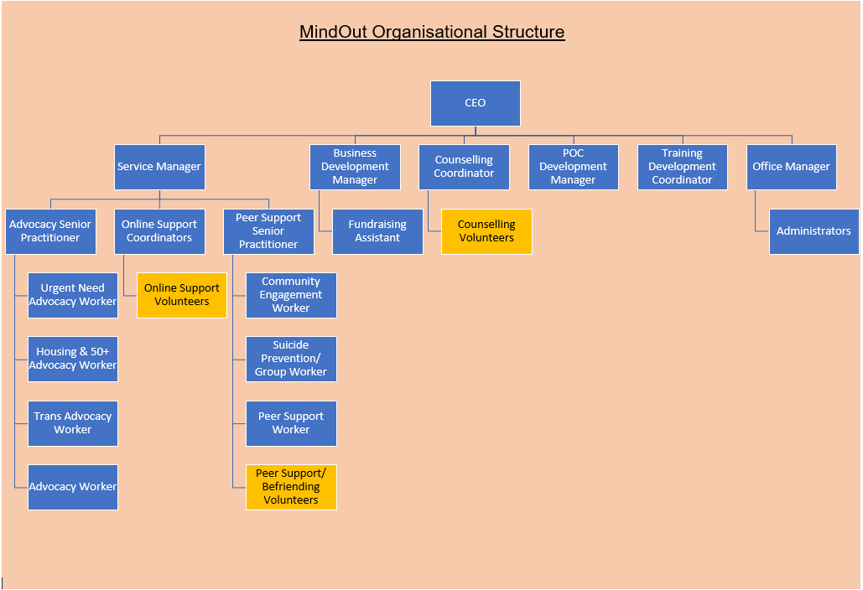

Please complete in type or black ink

Application for the appointment of: | Online Service Coordinator

PERSONAL DETAILS (IN BLOCK CAPITAL LETTERS)

SURNAME & TITLE |  |  |  |  |  |  |  | ADDRESS
Preferred Pronoun
FIRST NAME
TEL Home: |  |  |  |  | Work: |  |  |  | Mobile:
Email
If you are currently employed, may we contact you discreetly at work? |  |  |  |  |  |  |  |  |  |  | Yes/No

EDUCATION AND TRAINING

Please give details of your educational qualifications and experience including short courses where appropriate. Please continue on additional sheets if you need to expand this section.
Venue | Date | Courses/Qualifications

EMPLOYMENT HISTORY (INCLUDING VOLUNTARY WORK)

List in date order with present or most recent first
Please continue on additional sheets if you need to expand this section.

Name and Address of Employer | Job title and brief description of responsibilities | From | To | Reasons for leaving

If you are currently employed, please state your notice period:

GAPS IN EDUCATION/EMPLOYMENT HISTORY

If you have any gaps of 6 months or more in your education/employment history, please let us know in the following table. Please continue on additional sheets if you need to expand this section.

From | To | Reasons for gap

KNOWLEDGE, SKILLS AND EXPERIENCE RELEVANT TO THE POST

This is the most important part of the form. The person specification lists the knowledge and skills you need to do the job. These will not necessarily be gained through paid employment. They can also be gained through voluntary work and life experience. If you do not meet all the criteria it is unlikely that you will be short listed for interview.
When completing this section it is useful to use the criteria listed in the person specification as headings and under these please give examples by referring to your professional, academic, personal life or voluntary work. Use extra sheets if you need to and make sure they are clearly marked with your name and the title of the job for which you are applying.
Knowledge, skills and experience relevant to the post: Statement

Knowledge, skills and experience relevant to the post (continuation)

I confirm that to the best of my knowledge the information given on this form is true and correct and can be treated as part of any subsequent contract of employment.

Signature |  | Date:

REFERENCES

Please give details of two people to whom we can apply for references concerning your suitability for this post. One of these should be your current or most recent employer. Please note we DO NOT accept friends or family members as referees. If you do not wish us to contact either referee before informing you, please make this clear. Any offer of employment will be subject to satisfactory references.
Name: |  |  | Name:
Job Title: |  |  | Job Title:
In what capacity do you know them? |  |  | In what capacity do you know them?
Address: |  |  | Address:
Post code: |  |  | Post code:
Telephone: |  |  | Telephone:
E-mail: |  |  | E-mail
Can we contact before interview? |  |  | Can we contact before interview?

APPLICANTS WITH DISABILITIES
MindOut LGBTQ Mental Health Service is committed to employing people with disabilities. Please state any arrangements we can make to assist you, if called for interview or appointed to the post:

Disciplinary /Criminal Record
MindOut undertakes not to discriminate unfairly against any subject of a Disclosure on the basis of conviction or other information revealed.
Disciplinary: Have you ever been the subject of disciplinary action in the past? No Yes
If Yes, please give details below
Date | Employer | Subject | Outcome

Convictions: Have you ever been cautioned by the police or convicted of a criminal offence? No Yes

Have you ever been referred to the children’s or adult’s ‘barred’ list? No Yes

If Yes to either question, please give details on a separate sheet. Note, this should exclude any spent convictions under Section 4(2) of the Rehabilitation of Offenders Act 1974, unless the job for which you are applying involves working directly with vulnerable adults, in which case both spent and unspent convictions cautions, bind overs and pending prosecutions must be declared.

PRIVACY NOTICE
MindOut needs to keep and process information about you for the purposes of considering your job application.

This includes information enabling us to consider your suitability for the role; in order to comply with any legal requirements; to pursue the Legitimate Interests of the Charity and to protect our legal position in the event of legal proceedings.

The sort of information we hold includes your contact details; your application form and references; correspondence with or about you; and your performance in any interview(s), if offered.

Much of the information we hold will have been provided by you, but some may come from other sources, such as interviewers and referees.

We may process special categories of information, including (but not limited to) your racial or ethnic origin, political opinions, religious and philosophical beliefs, trade union membership, biometric data or sexual orientation. Our handling of this data will be subject to our Equal Opportunities in Employment policy, and will be done on the Legal Basis of Legitimate Interest on condition of Article 9(2):b; j of the GDPR.

We may also process data about criminal offences. Our handling of this data will be done on the Legal Basis of Legitimate Interest on condition of Article 10 of the GDPR, consistent with applicable Employment Law.

We will keep data relating to your application for up to one year. This is to allow us time to process your application, including if the same or a similar post is re-recruited and you wish to apply; to fulfil our Equal Opportunities in Employment policy; and to protect our legal position in the event of legal proceedings.

You have various rights considering your data under the relevant legislation, including the right to be informed; the right of access; the right to rectification; the right to erase; the right to restrict processing; the right to data portability; the right to object; rights in relation to automated decision making and profiling. For more information about your rights, please contact us and/or consult the Information Commissioner's Office.

THIS SECTION WILL BE DETACHED AND WILL NOT BE SEEN BY THE SELECTION PANEL. IT WILL BE USED ONLY FOR MONITORING PURPOSES

EQUAL OPPORTUNITIES IN EMPLOYMENT – STATEMENT OF POLICY
MindOut LGBTQ Mental Health Service is an equal opportunities employer and will apply objective criteria to assess merit. MindOut aims to ensure that no job applicant or employee receives less favourable treatment on the grounds of nationality, religion, ethnicity, gender, gender expression, marital status, pregnancy or maternity, sexual orientation, age or disability or is disadvantaged by conditions or requirements which cannot be shown to be justifiable. MindOut is particularly concerned not to discriminate against applicants who have lived experience of mental health issues.
Selection criteria and procedures will be reviewed frequently to ensure that individuals are selected, promoted and treated on the basis of their relevant merits and abilities. All employees will be given equal opportunity and where appropriate and possible, special training to enable them to progress within and outside the organisation. MindOut is committed to a programme of action to make this policy fully effective.
Would you please provide the following information which will be treated as confidential but which will assist us to monitor and implement our Equal Opportunities Policy. Your application will not be affected by the information provided or if you choose not to complete part or all of this section.

APPLICATION FOR THE POST OF:

Please state here where you saw the post advertised

DOB:

How would you describe your gender?
Female |  | Male |  | Non-binary |  |  | Queer
Unsure |  | Other – please state:

Do you or have you ever identified as transgender? |  | Yes |  | No

How would you describe your sexual orientation?

Bisexual |  | Gay |  | Heterosexual |  |  | Lesbian |  | Queer
Other – please state:

Which category best describes your ethnic or cultural origin?

Asian |  | Mixed |  | White
Asian British |  | Asian & White |  | British
Bangladeshi |  | Black African & White |  | Irish
Indian |  | Black Caribbean & White |  | European
Pakistani |  | Other |  | Other
Other
Black |  | Chinese or Other Ethnic Group
Black British |  | Chinese |  | Gypsy
African |  | Arab |  | Traveller
Caribbean |  | Jewish |  | Other
Sudanese

If you have a religious or other belief how would you describe it?

Agnostic |  | Christian |  | Jewish |  | Sikh
Atheist |  | Hindu |  | Muslim |  | Other
Buddhist |  | Jain |  | Pagan
Other belief:

Are your day to day activities limited because of a health problem or disability which has lasted, or is expected to last, at least 12 months?

Yes a little |  | Yes a lot |  | No (don’t answer next question)
If you answered yes, please state the type of impairment. If you have more than one, please indicate all that apply. If none apply, please mark “other” and write an answer in (examples given as guidance)

Developmental condition |  | Mental health condition |  |  | Physical impairment
Learning disability/difficulty |  | Long standing illness |  |  | Other (please sate)

