Community Base
113 Queens Road
Brighton
BN1 3XG

t: 01273 234839
e: info@mindout.org.uk

reg. company no. 7441667
Charity Number 1140098

November 2021
Dear Applicant,

Thank you for your interest in the post of Counselling Service Assistant at MindOut.

MindOut is looking for an experienced, proactive counsellor to help run our low-cost community counselling service. You will join the Counselling Services Manager to support a team of 20+ volunteer counsellors, assess new applicants and prepare matches. You will work alongside the general administration team to facilitate the day-to-day running of the service.

This is an excellent opportunity to help run an established, much needed community service, within an award-winning small charity.

Enclosed with the application pack are:
- a job description and person specification
- background information about MindOut
- an application form

If you would like this information in another format, e.g. large print or audio, please let us know.

The post is offered either part-time or full-time, a minimum of 14 hours and maximum of 35 hours per week, including occasional evening and weekend work. Please make your availability clear in your application. The salary is £25,402 pa pro rata paid monthly in arrears, for the first 6 months. The salary will then rise to £27,500 pa pro rata depending on successful probationary appraisal.

The post holder will be based in our office at Community Base in central Brighton with some working from home - some in-person working will be mandatory.

Holiday entitlement is 29 days a year pro rata excluding Bank Holidays. MindOut provides a 5% contribution to a group pension scheme to match employee contribution. The post is subject to a probationary period of 6 months. Appointment is subject to an enhanced DBS check.

Applications will be judged according to the criteria of the job description and person specification as required by our Equality, Diversity & Inclusion and Recruitment Policies. Please make sure you answer every point in the person specification on your application form.

Please return your completed application to recruitment@mindout.org.uk. . I regret we are unable to accept late applications. The closing date for applications is 5pm on Monday 6th December and interviews will be held on Monday 13th December.

Yours sincerely,
Helen Jones
CEO
Job Description

Job Title: Counselling Service Assistant
Responsible to: Counselling Services Manager

Summary of Duties
To support the Counselling Services Manager to recruit and support the volunteer team; to administer and process client applications, offer assessments and prepare referrals for allocation; to help manage a client waiting list; to support smooth running of the service and adherence to quality standards.

Main tasks, Project related
- to assist the Counselling Services Manager to recruit, support, induct, coordinate and manage volunteer counsellors
- to process client applications for online and for face-to-face counselling
- to record and store client information
- to assess clients for allocation to trainee counsellors
- to support allocation of clients to counsellors
- to assist with planning and coordinating training for volunteer counsellors
- to liaise with counselling training institutions including providing information on behalf of student counsellors
- to attend and minute monthly counselling team meetings (usually first Tuesday of the month, from 7pm)
- to ensure the counselling service adheres to MindOut’s internal policies and procedures
- to maintain strict confidentiality with regard to information given by and information about clients
- to publicise and promote the counselling service
- to contribute to monthly monitoring reports and waiting list update
- to assist in evaluating the impact and quality of the counselling service
- to participate in other MindOut activities and events as required e.g. Brighton Pride

General Responsibilities
- to attend as appropriate meetings with the Counselling Services Manager, staff team etc.
- to carry out other such tasks as appropriate in negotiation with the Counselling Services Manager which may be reasonably expected
- carry out all responsibilities with regard to MindOut’s Equality, Diversity and Anti-discrimination Policy and all other policies
- to participate in relevant training and self-development

This job description will be reviewed periodically with the post holder to take account of changing demands.

PERSON SPECIFICATION
See below the experience, skills, knowledge and competencies required to carry out the tasks described within the job description. Please ensure that you use examples to demonstrate how you meet each individual criterion on your application form. It is helpful to use the numbered heading below. Criteria marked ‘A’ will be used to shortlist candidates and criteria marked ‘I’ will be assessed during the interview stage. Criteria marked E are Essential to the role, D are desirable for the role.
 | Education and Training | Assess  ment  Process | Essential  or  Desirable
1 | Counselling qualification to diploma level (pending qualifications may be considered at our discretion) | A&I | E
 | Experience
2 | Experience and an understanding of mental health issues. Personal experience will be viewed positively | A&I | E
3 | Personal understanding and experience of lesbian, gay, bisexual, trans and queer identities | A&I | E
4 | Experience of working within voluntary sector counselling services | A&I | D
5 | Experience of online counselling | A&I | E
6 | Experience of recruiting, managing and training volunteers | A&I | D
7 | Experience of the assessment of clients for counselling and the issues to cover with a client in the first assessment session | A&I | D
8 | Experience of considering ethical dilemmas and supporting other counsellors in their clinical practice or with ethical dilemmas | A&I | E
9 | Experience of and commitment to working within the BACP’s Framework for Good Practice | A&I | E
10 | Experience of an affirmative approach to LGBTQ mental health issues | A& I | E
 | Skills and Abilities
11 | Ability to prioritise and organise own work and can use own initiative | A&I | E
12 | Ability to engage with vulnerable adults and people in distress | A&I | E
13 | Ability to establish and maintain positive professional boundaries | A&I | E
14 | Written and oral communication is concise and accurate | A&I | E
15 | Personal qualities including empathy, integrity, humility and able to self reflect | A&I | E
16 | Ability to work flexibly as part of a team, supportive and able to understand impact of role on others | A&I | E
17 | Prepared to work flexibly including occasional evenings | A | E
18 | Strong communication and interpersonal skills and the ability to develop and maintain relationships with a wide range of colleagues and organisations | A&I | E
19 | Excellent administrative skills, including IT, in order to manage complex client data | A&I | E
 | Knowledge
20 | Understanding of the need for and methods for monitoring and evaluating the effectiveness of project delivery | A & I | E
21 | Understanding of and demonstrable commitment to equal opportunities and understanding of diversity within LGBTQ communities | A&I | E

MindOut Recruitment information November 2021
Who we are

MindOut is run by and for LGBTQ people with experience of mental health issues. Our services are impartial, independent, non-judgmental and confidential. Service user participation is key in all aspects of planning, delivery and governance of the organisation and its services.

Our Vision is a world where the mental health of LGBTQ communities is a priority, free from stigma, respected and recognised.

Our Mission is to improve the wellbeing of LGBTQ people who experience mental health issues, reduce mental health stigma, and promote positive mental health amongst LGBTQ communities.

Our aims are to:
- improve mental wellbeing for LGBTQ people
- reduce social isolation in LGBTQ communities
- reduce suicidal distress in LGBTQ communities
- reduce stigma associated with mental health
- improve mental health services for LGBTQ people

Our values and principles are:
- MindOut is run by and for LGBTQ people with lived experience of mental health issues
- wellbeing includes all aspects of mental, physical and emotional health, across the whole range of mental health issues
- LGBTQ mental health is a collective concern for LGBTQ communities
- we work to promote equality and the diversity of our communities and the principle of accessible and safe spaces
- our work is co-produced by service users, volunteers and staff; this applies to research, development, design, promotion and delivery
- service users are engaged at all levels of the organisation and supported to volunteer, apply for paid work and become Trustees
- we work to continuously improve all we do
- we invest in our workforce

Our services include:
- advice and information
- mental health advocacy, including urgent need advocacy
- trans specific advocacy
- peer support group work
- peer mentoring and befriending
- a low cost counselling service
- on-line support
- wellbeing courses and workshops
- suicide prevention initiatives, including Out of the Blue peer support group
- social groups and outings
- LGBTQ affirmative practice training and trans awareness training

MindOut’s History

MindOut is 22 years old. For the first 12 years, MindOut was a project within Mind in Brighton and Hove. From 1st April 2011 MindOut became an independent organisation, a charity and a company limited by guarantee.

Staff Team

The MindOut staff team consists of the Chief Executive, Service Manager, Advocacy Senior Practitioner, Peer Support Senior Practitioner, Counselling Services Manager, Office Manager three Advocacy Workers, Suicide Prevention Worker, Online Service Coordinator, Business Development Manager, Fundraising Assistant and two Administrators. See structure diagram below.

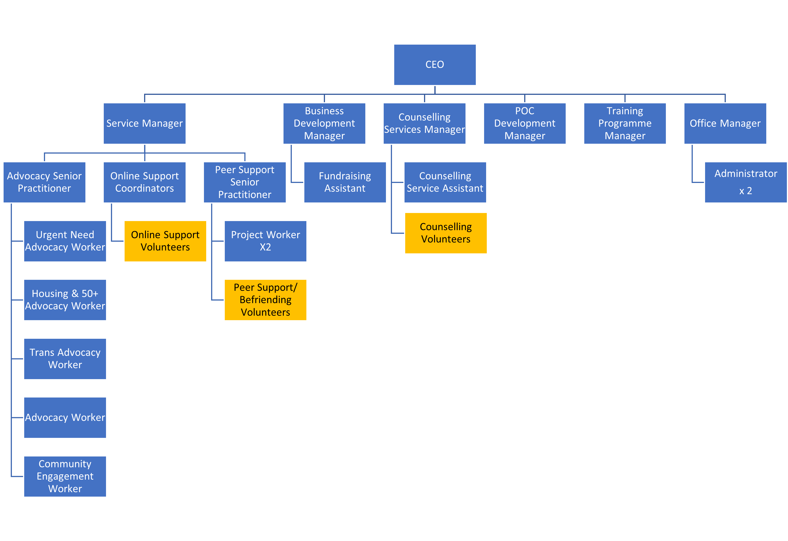

Volunteer Teams

Currently MindOut has approx. 50 volunteers working on the Counselling, Peer Mentoring, telephone befriending, online and group work services.

Board of Trustees

MindOut’s Executive Committee has 12 Trustees, led by our Chair, Simon Fillery

.

Please complete in type or black ink

Application for the appointment of:

PERSONAL DETAILS (IN BLOCK CAPITAL LETTERS)

SURNAME & TITLE |  |  |  |  |  |  |  | ADDRESS
Preferred Pronoun
FIRST NAME
TEL Home: |  |  |  |  | Work: |  |  |  | Mobile:
Email
How many hours are you available for? (14-35 hours per week)
If you are currently employed, may we contact you discreetly at work?

EDUCATION AND TRAINING

Please give details of your educational qualifications and experience including short courses where appropriate. Please continue on additional sheets if you need to expand this section.

Venue | Date | Courses/Qualifications

EMPLOYMENT HISTORY (INCLUDING VOLUNTARY WORK)

List in date order with present or most recent first
Please continue on additional sheets if you need to expand this section.

Name and Address of Employer | Job title and brief description of responsibilities | From | To | Reasons for leaving

If you are currently employed, please state your notice period:

GAPS IN EDUCATION/EMPLOYMENT HISTORY

If you have any gaps of 6 months or more in your education/employment history, please let us know in the following table. Please continue on additional sheets if you need to expand this section.

From | To | Reasons for gap

KNOWLEDGE, SKILLS AND EXPERIENCE RELEVANT TO THE POST

This is the most important part of the form. The person specification lists the knowledge and skills you need to do the job. These will not necessarily be gained through paid employment. They can also be gained through voluntary work and life experience. If you do not meet all the criteria it is unlikely that you will be short listed for interview.
When completing this section it is useful to use the criteria listed in the person specification as headings and under these please give examples by referring to your professional, academic, personal life or voluntary work. Use extra sheets if you need to and make sure they are clearly marked with your name and the title of the job for which you are applying.

Knowledge, skills and experience relevant to the post: Statement

I confirm that to the best of my knowledge the information given on this form is true and correct and can be treated as part of any subsequent contract of employment.

Signature |  | Date:

REFERENCES

Please give details of two people to whom we can apply for references concerning your suitability for this post. One of these should be your current or most recent employer. Please note we DO NOT accept friends or family members as referees. If you do not wish us to contact either referee before informing you, please make this clear. Any offer of employment will be subject to satisfactory references.
Name: |  |  | Name:
Job Title: |  |  | Job Title:
In what capacity do you know them? |  |  | In what capacity do you know them?
Address: |  |  | Address:
Post code: |  |  | Post code:
Telephone: |  |  | Telephone:
E-mail: |  |  | E-mail
Can we contact before interview? |  |  | Can we contact before interview?

APPLICANTS WITH DISABILITIES
MindOut LGBTQ Mental Health Service is committed to employing people with disabilities. Please state any arrangements we can make to assist you, if called for interview or appointed to the post:

Disciplinary /Criminal Record
MindOut undertakes not to discriminate unfairly against any subject of a Disclosure on the basis of conviction or other information revealed.
Disciplinary: Have you ever been the subject of disciplinary action in the past? No Yes
If Yes, please give details below
Date | Employer | Subject | Outcome

Convictions: Have you ever been cautioned by the police or convicted of a criminal offence? No Yes

Have you ever been referred to the children’s or adult’s ‘barred’ list? No Yes

If Yes to either question, please give details on a separate sheet. Note, this should exclude any spent convictions under Section 4(2) of the Rehabilitation of Offenders Act 1974, unless the job for which you are applying involves working directly with vulnerable adults, in which case both spent and unspent convictions cautions, bind overs and pending prosecutions must be declared.

PRIVACY NOTICE
MindOut needs to keep and process information about you for the purposes of considering your job application.

This includes information enabling us to consider your suitability for the role; in order to comply with any legal requirements; to pursue the Legitimate Interests of the Charity and to protect our legal position in the event of legal proceedings.

The sort of information we hold includes your contact details; your application form and references; correspondence with or about you; and your performance in any interview(s), if offered.

Much of the information we hold will have been provided by you, but some may come from other sources, such as interviewers and referees.

We may process special categories of information, including (but not limited to) your racial or ethnic origin, political opinions, religious and philosophical beliefs, trade union membership, biometric data or sexual orientation. Our handling of this data will be subject to our Equal Opportunities in Employment policy, and will be done on the Legal Basis of Legitimate Interest on condition of Article 9(2):b; j of the GDPR.

We may also process data about criminal offences. Our handling if this data will be done on the Legal Basis of Legitimate Interest on condition of Article 10 of the GDPR, consistent with applicable Employment Law.

We will keep data relating to your application for up to one year. This is to allow us time to process your application, including if the same or a similar post is re-recruited and you wish to apply; to fulfil our Equal Opportunities in Employment policy; and to protect our legal position in the event of legal proceedings.

You have various rights considering your data under the relevant legislation, including the right to be informed; the right of access; the right to rectification; the right to erase; the right to restrict processing; the right to data portability; the right to object; rights in relation to automated decision making and profiling. For more information about your rights, please contact us and/or consult the Information Commissioner's Office.

THIS SECTION WILL BE DETACHED AND WILL NOT BE SEEN BY THE SELECTION PANEL. IT WILL BE USED ONLY FOR MONITORING PURPOSES

EQUAL OPPORTUNITIES IN EMPLOYMENT – STATEMENT OF POLICY
MindOut LGBTQ Mental Health Service is an equal opportunities employer and will apply objective criteria to assess merit. MindOut aims to ensure that no job applicant or employee receives less favourable treatment on the grounds of nationality, religion, ethnicity, gender, gender expression, marital status, pregnancy or maternity, sexual orientation, age or disability or is disadvantaged by conditions or requirements which cannot be shown to be justifiable. MindOut is particularly concerned not to discriminate against applicants who have lived experience of mental health issues.
Selection criteria and procedures will be reviewed frequently to ensure that individuals are selected, promoted and treated on the basis of their relevant merits and abilities. All employees will be given equal opportunity and where appropriate and possible, special training to enable them to progress within and outside the organisation. MindOut is committed to a programme of action to make this policy fully effective.
Would you please provide the following information which will be treated as confidential but which will assist us to monitor and implement our Equal Opportunities Policy. Your application will not be affected by the information provided or if you choose not to complete part or all of this section.

APPLICATION FOR THE POST OF:

Please state here where you saw the post advertised

DOB:

How would you describe your gender?
Female |  | Male |  | Non-binary |  |  | Queer
Unsure |  | Other – please state:

Do you or have you ever identified as transgender? |  | Yes |  | No

How would you describe your sexual orientation?

Bisexual |  | Gay |  | Heterosexual |  |  | Lesbian |  | Queer
Other – please state:

Which category best describes your ethnic or cultural origin?

Asian |  | Mixed |  | White
Asian British |  | Asian & White |  | British
Bangladeshi |  | Black African & White |  | Irish
Indian |  | Black Caribbean & White |  | European
Pakistani |  | Other |  | Other
Other
Black |  | Chinese or Other Ethnic Group
Black British |  | Chinese |  | Gypsy
African |  | Arab |  | Traveller
Caribbean |  | Jewish |  | Other
Sudanese

If you have a religious or other belief how would you describe it?

Agnostic |  | Christian |  | Jewish |  | Sikh
Atheist |  | Hindu |  | Muslim |  | Other
Buddhist |  | Jain |  | Pagan
Other belief:

Are your day to day activities limited because of a health problem or disability which has lasted, or is expected to last, at least 12 months?

Yes a little |  | Yes a lot |  | No (don’t answer next question)
If you answered yes, please state the type of impairment. If you have more than one, please indicate all that apply. If none apply, please mark “other” and write an answer in (examples given as guidance)

Developmental condition |  | Mental health condition |  |  | Physical impairment
Learning disability/difficulty |  | Long standing illness |  |  | Other (please sate)

