Community Base
113 Queens Road
Brighton
BN1 3XG

t: 01273 234839
e: info@mindout.org.uk

Company Number 7441667
Charity Number 1140098

June 2022
Dear Applicant,

Thank you for your interest in the Communications and Marketing Officer post with MindOut.

Enclosed with the application pack are:
- a job description
- a person specification
- background information about MindOut
- a separate application form and equalities monitoring form

If you would like this information in another format, e.g. large print or in audio format please let us know.

The post is for 21 hours per week and is fixed term for 12 months with the aim of becoming permanent subject to funding. The hours can be worked flexibly by arrangement and may involve occasional evenings and weekends. The post holder will be based in our office at Community Base, 113 Queens Road, Brighton and/or working from home.

The salary for this post is £25,492 pa (£15,295 pro rata) during first six months, increasing to £28,325 (£16,995 pro rata) after probation is completed. MindOut provides up to 5% of salary contribution to pension scheme, depending on employee contribution. The post holder is entitled to 29 days leave per year pro rata, excluding Bank Holidays.

Applications will be judged according to how they meet the criteria of the job description, person specification and display a commitment to MindOut’s values as required by our Equality, Diversity and Inclusion Policy and Recruitment Policy. Please make sure your application speaks to every point in the person specification on your application form. All successful applicants are subject to an enhanced DBS check.

Please return your application form to us at recruitment@mindout.org.uk. I regret we are unable to accept late applications.

The closing date for applications is 12 noon on Monday 18th July 2022 and interviews will be held on Tuesday 26th July 2022.

Yours sincerely,

Rita Hirani
CEO

MindOut

Lesbian, Gay, Bisexual, Transgender and Queer Mental Health Service

Job Description

Job Title Communications and Marketing Officer
Reports to Office Manager
Hours 21 hours per week
Salary £28,325 pa (£16,995 pro rata)
Location Hybrid working; homeworking and office based
Contract Fixed Term
Benefits A generous package including 29 days holiday a year (pro rata)
and public holidays, employee pension scheme with up to 5%
employer contribution, flexible working and Employee Assistance

Purpose of role
We are looking for a Communications & Marketing Officer to review and implement our communications and social media strategies, particularly with regard to equality, diversity, inclusion and anti-racism. The main aims of this are for MindOut to communicate effectively with its beneficiaries, become the authoritative source of information relating to LGBTQ mental health in the UK and increase our capacity to attract potential donors. Reporting to the Office Manager and working alongside Service Managers and Fundraising, you will influence the national debate around LGBTQ mental health. At the same time, you will build connections and strengthen the MindOut community in line with our mission and charitable aims.

Key Responsibilities

- Review and implement the MindOut Communications Strategy, including social media, to build awareness and to maximise the reach of our services.
- Develop and deliver campaigns across a range of communications disciplines including media and public relations, advertising, marketing, digital and social media and production of some materials.
- Increase the charity’s profile across appropriate media (national, regional, social, print and broadcast).
- Coordinate our website content.

Main Tasks
- Act as initial point of contact for inbound media and communications enquiries.
- Write press releases and blog posts for the website.
- Produce the newsletter (minimum 4 per year).
- Work with the Office Manager on internal communications so that staff are involved with organisational developments
- Support other staff with copywriting, e.g. the annual report, posters, flyers, etc.
- Copywriting for communication to all stakeholder groups (volunteers, service users, staff, funders, corporate sponsors and LGBTQ communities)
- Identify, write and disseminate newsworthy stories and press releases for MindOut.
- Create and maintain quotes and case studies for use in PR and marketing, dealing sensitively with those whose personal experiences might be featured
- Develop key messages, schedule posts, design content, engage in current debates about mental health.
- Consider accessibility of content for those who are neurodiverse, deaf/hard of hearing and/or blind/have limited vision.
- Respond to comments, build followers, increase calls to action and build community.
- Position, influence and engage with relevant debates and establish MindOut as the leading ‘voice’ as experts on LGBTQ mental health.
- Coordinate campaigns with partners to amplify the message.
- Support the management team with crisis situation communications including strategy, holding statements, Q&As
- Identify issues that could potentially damage the organisation’s reputation
- Monitor online metrics and analytics.

General Responsibilities
- Attend as appropriate meetings with the CEO, management team, staff team and Trustees
- Carry out other appropriate tasks agreed with line management
- Comply with MindOut’s policies, procedures, management and monitoring systems.
- Identify your own training and development needs which MindOut will support you with and participate in relevant training and self-development
- To be responsible for undertaking your own administration

This job description will be reviewed periodically with the postholder to take account of changing demands.
PERSON SPECIFICATION
See below the experience, skills, knowledge and behaviours required to carry out the tasks described within the job description. When writing your application, please share examples of how you meet each of the points below. If you are interested in applying but aren’t sure that you have all of the skills and experience, please do still apply. We are open to learning on the job and supporting the development of the successful candidate so that they are able to do the job to the best of their ability.

 | Essential / Desirable
Skills

- Excellent marketing and communication skills | E
- Excellent attention to detail and proofreading skills | E
- Sound knowledge of social media, website best practice,mail campaigns e.g. Mailchimp and performance analytics | E
- IT and design skills | E
- Able to work accurately and to a deadline | E
- Able to organise tasks and work on own initiative | E
Experience

- Personal understanding and experience of lesbian, gay, bisexual, trans and queer mental health issues | E
- Communications experience, e.g. creating content for a range of audiences | E
- Experience of SEO and paid online advertising | D
Behaviours and knowledge

- Understands what makes for efficient and effective communication processes | E
- Excellent interpersonal skills and the ability to communicate well with a broad range of people, including those affected by mental health conditions. | E
- Cares about equality, diversity, inclusion and good customer service | E

MindOut Recruitment information June 2022
Who we are

MindOut is run by and for LGBTQ people with experience of mental health issues. Our services are impartial, independent, non-judgmental and confidential. Service user participation is key in all aspects of planning, delivery and governance of the organisation and its services.

Our Vision is a world where the mental health of LGBTQ communities is a priority, free from stigma, respected and recognised.

Our Mission is to improve the wellbeing of LGBTQ people who experience mental health issues, reduce mental health stigma, and promote positive mental health amongst LGBTQ communities.

Our aims are to:
- improve mental wellbeing for LGBTQ people
- reduce social isolation in LGBTQ communities
- reduce suicidal distress in LGBTQ communities
- reduce stigma associated with mental health
- improve mental health services for LGBTQ people

Our values and principles are:
- MindOut is run by and for LGBTQ people with lived experience of mental health issues
- wellbeing includes all aspects of mental, physical and emotional health, across the whole range of mental health issues
- LGBTQ mental health is a collective concern for LGBTQ communities
- we work to promote anti-racism, equity and the diversity of our communities and the principle of accessible and safe spaces
- our work is co-produced by service users, volunteers and staff; this applies to research, development, design, promotion and delivery
- service users are engaged at all levels of the organisation and supported to volunteer, apply for paid work and become Trustees
- we work to continuously improve all we do
- we invest in our workforce

Our services include:
- advice and information
- mental health advocacy, including urgent need advocacy
- trans specific advocacy
- peer support group work
- peer mentoring and befriending
- a low cost counselling service
- on-line support
- wellbeing courses and workshops
- suicide prevention initiatives, including Out of the Blue peer support group
- social groups and outings
- LGBTQ affirmative practice training and trans awareness training

MindOut’s History

MindOut is 22 years old. For the first 12 years, MindOut was a project within Mind in Brighton and Hove. From 1st April 2011 MindOut became an independent organisation, a charity and a company limited by guarantee.

Staff Team

The MindOut paid staff team currently consists of the Chief Executive, Service Manager, Advocacy Service Manager, Wellbeing Service Manager, Wellbeing Project Workers, People of Colour Development Manager, Counselling Manager, Counselling Assistant, Advocacy Workers, Online Service Manager, Business Development Manager, Fundraising Assistant, Training Programme Manager, Office Manager and Administrators. See the structure diagram below:

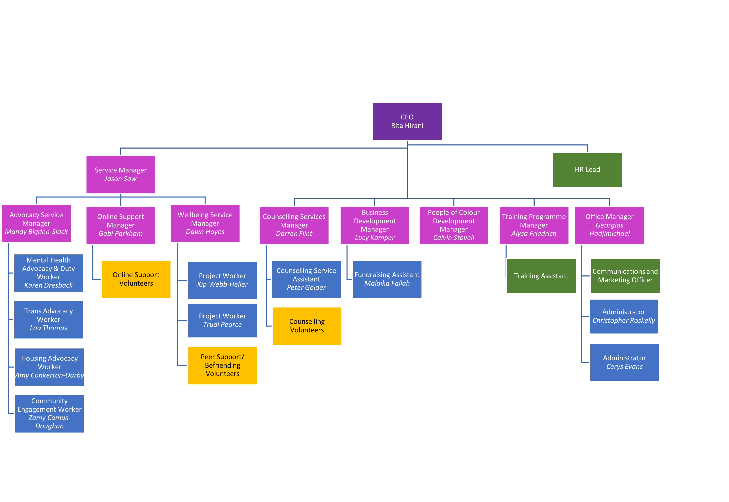Volunteer Teams

Currently MindOut has approx. 50 volunteers working in the Counselling, Peer Mentoring, telephone befriending, online and group work services.

Board of Trustees

MindOut’s Executive Committee has 12 Trustees, led by our Chair, Simon Fillery.

