Community Base
113 Queens Road
Brighton
BN1 3XG

t: 01273 234839
e: info@mindout.org.uk

Company Number 7441667
Charity Number 1140098

June 2022
Dear Applicant,

Thank you for your interest in the HR Lead post with MindOut.

Enclosed with the application pack are:
- a job description
- a person specification
- background information about MindOut
- a separate application form and equalities monitoring form

If you would like this information in another format, e.g. large print or in audio format please let us know.

The post is for 14 hours per week and is fixed term for 12 months with the aim of becoming permanent subject to funding. Freelance consultants are welcome to apply. The hours can be worked flexibly by arrangement and may involve occasional evenings and weekends. The post holder will be based in our office at Community Base, 113 Queens Road, Brighton and/or working from home.

The salary for this post is £30,600 pa (£12,240 pro rata) for the first six months, increasing to £34,000 pa (£13,600 pro rata) after probation is complete. MindOut provides up to 5% of salary contribution to pension scheme, depending on employee contribution. The post holder is entitled to 29 days leave per year pro rata, excluding Bank Holidays.

Applications will be judged according to how they meet the criteria of the job description, person specification and display a commitment to MindOut’s values as required by our Equality, Diversity and Inclusion Policy and Recruitment Policy. Please make sure your application speaks to every point in the person specification on your application form. All successful applicants are subject to an enhanced DBS check.

Please return your application form to us at recruitment@mindout.org.uk. I regret we are unable to accept late applications.

The closing date for applications is 12 noon on Monday 18th July 2022 and interviews will be held on Monday 25th July 2022.

Yours sincerely,

Rita Hirani
CEO

MindOut

Lesbian, Gay, Bisexual, Transgender and Queer Mental Health Service

Job Description

Job Title HR Lead
Reports to CEO (subject to change)
Hours 2 days (14 hours) per week
Salary £34,000
Location Hybrid working; one day homeworking and one day in office
Contract Fixed Term/Freelance
Benefits A generous package including 29 days holiday a year (pro rata)
and public holidays, employee pension scheme with up to 5%
employer contribution, flexible working and Employee Assistance

Purpose of role
MindOut is a well-established, small charity run by and for LGBTQ people who experience mental health issues. We offer unique and highly effective, evidence-based mental health support through a range of services. We have a great reputation and ambitious plans for the future; to expand and diversify our services, reach more marginalised communities and develop our training and anti-stigma work.
We are seeking a HR Lead to join our management team and guide us through the next phase of our transformation and growth.
Key Responsibilities
We are looking for an HR professional to provide exceptional support to staff at MindOut. You will act as a subject matter expert and trusted advisor on people matters and will lead the delivery of HR.

Main Tasks
- Deliver effective and efficient HR support, with a particular focus on supporting change processes, talent and resourcing, performance management and employee relations.
- Provide HR advice and guidance to the management team and ensure strong processes, practices and policies are in place to support this.
- Leading and overseeing all aspects of people operations, including pay, reward and recognition, EDI, employee relations matters, proactive management of sickness absence, review of people policies and practices.
- Promote employee engagement and wellbeing ensuring that staff are aware of the wellbeing support available to them.
- Oversee staff support systems e.g. Employee Assistance Programme, company pension, external supervision contracts, staff training and support service managers in relation to staff performance, capabilities and reviews and contracts.
- Working with the Office Manager, support the recruitment process to ensure that candidates receive a professional, high-quality service and positive impressions of the organisation.
- Support the CEO and management team with change management activities.
- Embed MindOut’s Equality, Diversity and Inclusion strategy and Anti-Racism strategy in organisational policies and procedures.
- Provide leadership, direction, coaching and guidance that enables managers to make sound resourcing decisions.
- Act as lead officer on the Trustee Board’s ‘People and Culture’ Committee.
- Support managers to ensure staff Wellness Action Plans are monitored and implemented.
- Working with the Training team, develop programmes and advise on strategies for staff investment and talent development.
- Keeping up to date with HR good practice and legislation.

General Responsibilities
- Attend as appropriate meetings with the CEO, management team, staff team and Trustees
- Carry out other appropriate tasks agreed with line management
- Comply with MindOut’s policies, procedures, management and monitoring systems
- Lead on developing policies in relation to HR and ensure policies are up to date and meet good practice standards
- Identify your own training and development needs which MindOut will support you with and participate in relevant training and self-development
- To be responsible for undertaking your own administration

This job description will be reviewed periodically with the postholder to take account of changing demands.
PERSON SPECIFICATION
See below the experience, skills, knowledge and behaviours required to carry out the tasks described within the job description. When writing your application, please share examples of how you meet each of the points below. If you are interested in applying but aren’t sure that you have all of the skills and experience, please do still apply. We are open to learning on the job and supporting the development of the successful candidate so that they are able to do the job to the best of their ability.

 | Essential / Desirable
Skills
- Excellent interpersonal skills and the ability to communicate effectively with a broad range of people, including those affected by mental health conditions | E
- Able to advise, influence and challenge managers to achieve strong outcomes | E
- Excellent literacy and numeracy skills and attention to detail | E
- Able to work accurately and to a deadline | E
- Able to plan, schedule and prioritise work using own initiative | E
Experience
- Personal understanding and experience of lesbian, gay, bisexual, trans and queer mental health issues | E
- Previous experience of leading an HR or People function, including leading or overseeing employee relations cases | E
- Experience of leading or overseeing the implementation of new HR systems, policies and processes | D
Behaviours and knowledge
- Strong knowledge of employment and HR good practice | E
- Demonstrable commitment to advancing equality, diversity and inclusion in the workplace | E
- A good understanding of the importance of confidentiality, the principles of data protection and GDPR requirements | E
- A high level of emotional intelligence, resilience and able to adapt to a changing environment and growth | E
- A ‘can do’ approach | E
- CIPD or HR qualification | D

MindOut Recruitment information June 2022
Who we are

MindOut is run by and for LGBTQ people with experience of mental health issues. Our services are impartial, independent, non-judgmental and confidential. Service user participation is key in all aspects of planning, delivery and governance of the organisation and its services.

Our Vision is a world where the mental health of LGBTQ communities is a priority, free from stigma, respected and recognised.

Our Mission is to improve the wellbeing of LGBTQ people who experience mental health issues, reduce mental health stigma, and promote positive mental health amongst LGBTQ communities.

Our aims are to:
- improve mental wellbeing for LGBTQ people
- reduce social isolation in LGBTQ communities
- reduce suicidal distress in LGBTQ communities
- reduce stigma associated with mental health
- improve mental health services for LGBTQ people

Our values and principles are:
- MindOut is run by and for LGBTQ people with lived experience of mental health issues
- wellbeing includes all aspects of mental, physical and emotional health, across the whole range of mental health issues
- LGBTQ mental health is a collective concern for LGBTQ communities
- we work to promote anti-racism, equity and the diversity of our communities and the principle of accessible and safe spaces
- our work is co-produced by service users, volunteers and staff; this applies to research, development, design, promotion and delivery
- service users are engaged at all levels of the organisation and supported to volunteer, apply for paid work and become Trustees
- we work to continuously improve all we do
- we invest in our workforce

Our services include:
- advice and information
- mental health advocacy, including urgent need advocacy
- trans specific advocacy
- peer support group work
- peer mentoring and befriending
- a low cost counselling service
- on-line support
- wellbeing courses and workshops
- suicide prevention initiatives, including Out of the Blue peer support group
- social groups and outings
- LGBTQ affirmative practice training and trans awareness training
MindOut’s History
MindOut is 22 years old. For the first 12 years, MindOut was a project within Mind in Brighton and Hove. From 1st April 2011 MindOut became an independent organisation, a charity and a company limited by guarantee.

Staff Team

The MindOut paid staff team currently consists of the Chief Executive, Service Manager, Advocacy Service Manager, Wellbeing Service Manager, Wellbeing Project Workers, People of Colour Development Manager, Counselling Manager, Counselling Assistant, Advocacy Workers, Online Service Manager, Business Development Manager, Fundraising Assistant, Training Programme Manager, Office Manager and Administrators. See the structure diagram below:
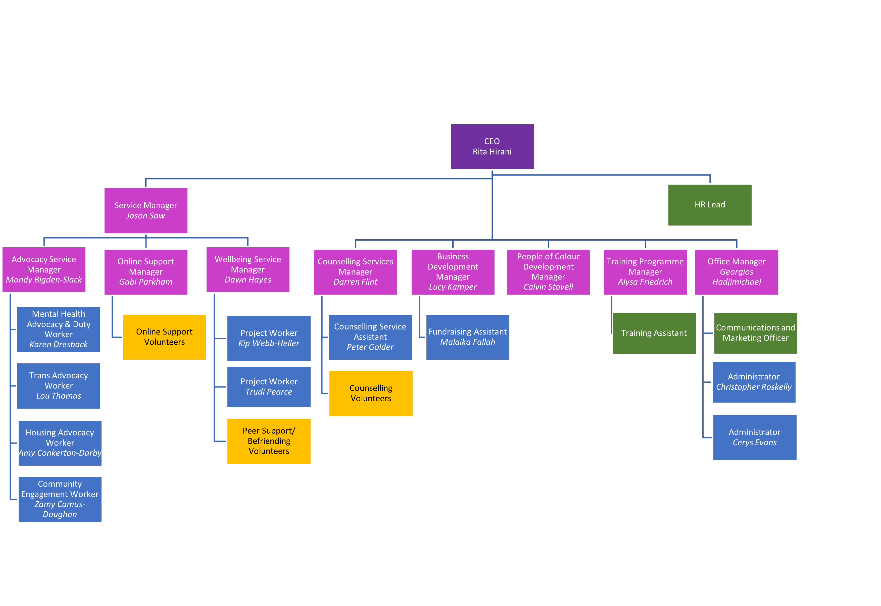Volunteer Teams

Currently MindOut has approx. 50 volunteers working in the Counselling, Peer Mentoring, telephone befriending, online and group work services.

Board of Trustees

MindOut’s Executive Committee has 12 Trustees, led by our Chair, Simon Fillery.

