Community Base
113 Queens Road
Brighton
BN1 3XG

t: 01273 234839
e: info@mindout.org.uk

Company Number 7441667
Charity Number 1140098

June 2022
Dear Applicant,

Thank you for your interest in the Training Assistant post with MindOut.

Enclosed with the application pack are:
- a job description
- a person specification
- background information about MindOut
- a separate application form and equalities monitoring form

If you would like this information in another format, e.g. large print or in audio format please let us know.

The post is for 21 hours per week and is fixed term for 12 months with the aim of becoming permanent subject to funding. The hours can be worked flexibly by arrangement and may involve occasional evenings and weekends. The post holder will be based in our office at Community Base, 113 Queens Road, Brighton and/or working from home.

The salary for this post is £21,321 pa (£12,792 pro rata) for the first six months, increasing to £23,690 (£14,214 pro rata) after the probation period is complete. MindOut provides up to 5% of salary contribution to pension scheme, depending on employee contribution. The post holder is entitled to 29 days leave per year pro rata, excluding Bank Holidays.

Applications will be judged according to how they meet the criteria of the job description, person specification and display a commitment to MindOut’s values as required by our Equality, Diversity and Inclusion Policy and Recruitment Policy. Please make sure your application speaks to every point in the person specification on your application form. All successful applicants are subject to an enhanced DBS check.

Please return your application form to us at recruitment@mindout.org.uk. I regret we are unable to accept late applications.

The closing date for applications is 12 noon on Wednesday 13th July 2022 and interviews will be held on Thursday 21st July 2022.

Yours sincerely,

Rita Hirani
CEO

MindOut

Lesbian, Gay, Bisexual, Transgender and Queer Mental Health Service

Job Description

Job Title Training Assistant
Reports to Training Programme Manager
Hours 21 hours per week
Salary £23,690 pa (£14,214 pro rata)
Location Hybrid working; homeworking and office based
Contract Fixed Term
Benefits A generous package including 29 days holiday a year (pro rata)
and public holidays, employee pension scheme with up to 5%
employer contribution, flexible working and Employee Assistance

Purpose of role
We are looking for a Training Assistant to support the Training Programme Manager to manage and develop a programme of LGBTQ awareness and mental health related topics.
MindOut is passionate about helping organisations and professionals to become more confident in supporting LGBTQ people, whether they are clients, customers, service users or staff. Our supportive learning environment encourages participants to reflect on and improve their professional and personal practices with regard to LGBTQ inclusion. Our focus on affirmative practice is at the heart of all of our training; affirmative practice embraces a positive view of (LGBTQ) identities and relationships and proactively addresses the negative influences on mental health that homophobia, transphobia, and heterosexism have on the lives of LGBTQ people.

Key Responsibilities
- to be responsible for Training Programme administrative tasks
- to develop and maintain efficient office systems

Main Tasks
- Respond to new inquiries via email
- Schedule sales calls for the Training Programme Manager
- Prepare sales meeting conversation templates
- Set up monthly Eventbrite training pages
- Set up Zoom links (15 monthly events)
- Monitor training page on website for updates and changes
- Send out resources for upcoming events
- Supply trainers with training materials and attendee lists
- Email attendees with resources, evaluation link, signposting, etc.
- Monitor ongoing evaluation reports
- Liaise with the Finance Officer to generate customer invoices
- Monitor outstanding unpaid invoices
- Track expected income via Donorfy software
- Create visual/video social media content
- Work with the Communications Officer to schedule social media via Hootsuite
- Update training programme tracking systems
- Work with the management team to organise staff and volunteer training

General Responsibilities
- Attend meetings with the CEO, management team, staff team and MindOut executive and sub committees as required
- Carry out other appropriate tasks agreed with line management
- Comply with MindOut’s policies, procedures, management and monitoring systems.
- Identify your own training and development needs and participate in relevant training and self-development.

This job description will be reviewed periodically with the postholder to take account of changing demands.
PERSON SPECIFICATION
See below the experience, skills, knowledge and behaviours required to carry out the tasks described within the job description. When writing your application, please share examples of how you meet each of the points below. If you are interested in applying but aren’t sure that you have all of the skills and experience, please do still apply. We are open to learning on the job and supporting the development of the successful candidate so that they are able to do the job to the best of their ability.

 | Essential / Desirable
Skills
- Strong communication and organisational skills | E
- Good attention to detail | E
- Good literacy and numeracy skills | E
- Able to organise tasks and work on own initiative | E
- Able to create and manage office systems | D
- Able to use a comprehensive range of IT software (Microsoft Office, Excel, Powerpoint etc) databases, websites and social media | E
Experience
- Personal understanding and experience of lesbian, gay, bisexual, trans and queer mental health issues | E
- Administrative experience | E
- Use of data monitoring systems | D
Behaviours and knowledge
- Interested in training, development and continued improvement | E
- Excellent interpersonal skills and the ability to communicate well with a broad range of people, including those affected by mental health conditions. | E
- Cares about equality, diversity, inclusion and good customer service | E

MindOut Recruitment information June 2022
Who we are

MindOut is run by and for LGBTQ people with experience of mental health issues. Our services are impartial, independent, non-judgmental and confidential. Service user participation is key in all aspects of planning, delivery and governance of the organisation and its services.

Our Vision is a world where the mental health of LGBTQ communities is a priority, free from stigma, respected and recognised.

Our Mission is to improve the wellbeing of LGBTQ people who experience mental health issues, reduce mental health stigma, and promote positive mental health amongst LGBTQ communities.

Our aims are to:
- improve mental wellbeing for LGBTQ people
- reduce social isolation in LGBTQ communities
- reduce suicidal distress in LGBTQ communities
- reduce stigma associated with mental health
- improve mental health services for LGBTQ people

Our values and principles are:
- MindOut is run by and for LGBTQ people with lived experience of mental health issues
- wellbeing includes all aspects of mental, physical and emotional health, across the whole range of mental health issues
- LGBTQ mental health is a collective concern for LGBTQ communities
- we work to promote anti-racism, equity and the diversity of our communities and the principle of accessible and safe spaces
- our work is co-produced by service users, volunteers and staff; this applies to research, development, design, promotion and delivery
- service users are engaged at all levels of the organisation and supported to volunteer, apply for paid work and become Trustees
- we work to continuously improve all we do
- we invest in our workforce

Our services include:
- advice and information
- mental health advocacy, including urgent need advocacy
- trans specific advocacy
- peer support group work
- peer mentoring and befriending
- a low cost counselling service
- on-line support
- wellbeing courses and workshops
- suicide prevention initiatives, including Out of the Blue peer support group
- social groups and outings
- LGBTQ affirmative practice training and trans awareness training

MindOut’s History

MindOut is 22 years old. For the first 12 years, MindOut was a project within Mind in Brighton and Hove. From 1st April 2011 MindOut became an independent organisation, a charity and a company limited by guarantee.

Staff Team

The MindOut paid staff team consists of the Chief Executive, Service Manager, Advocacy Service Manager, Wellbeing Service Manager, People of Colour Development Manager, Counselling Manager, Counselling Assistant, Advocacy Workers, Suicide Prevention/Group Worker, Online Service Manager, Business Development Manager, Fundraising Assistant, Training Programme Manager, Office Manager and Administrator. See the structure diagram below:

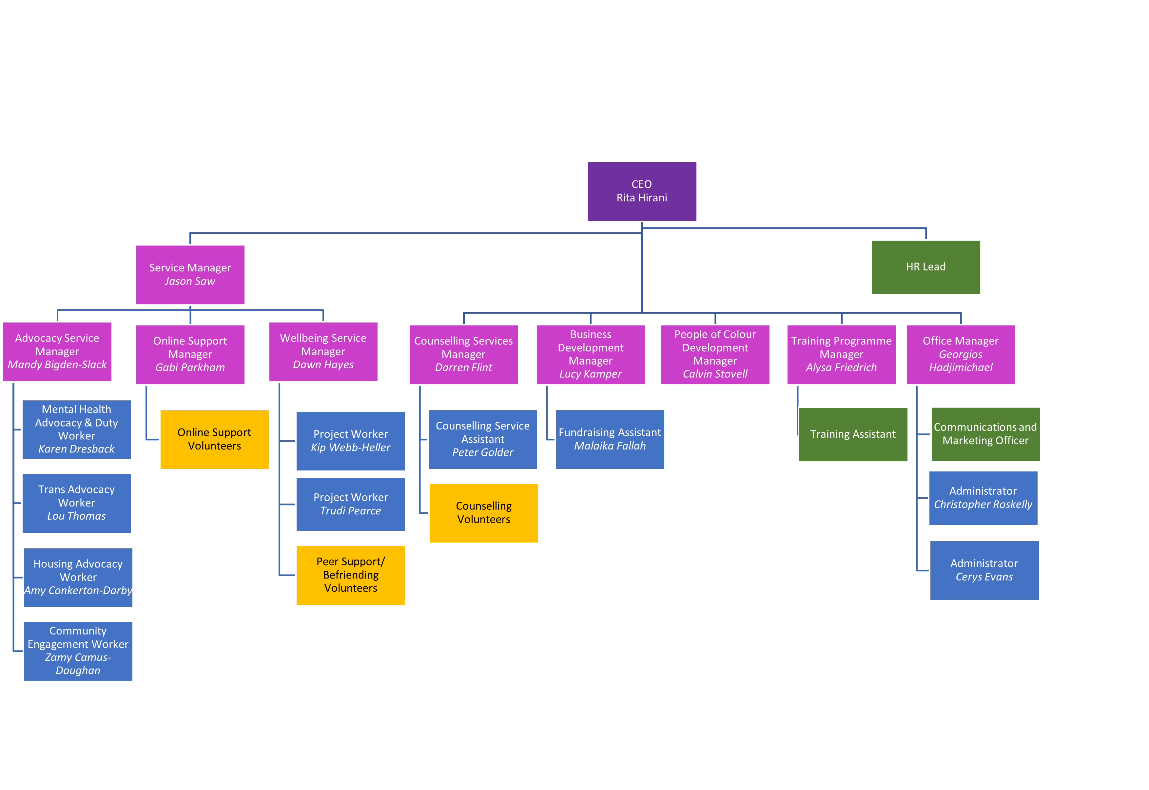Volunteer Teams

Currently MindOut has approx. 50 volunteers working in the Counselling, Peer Mentoring, telephone befriending, online and group work services.

Board of Trustees

MindOut’s Executive Committee has 12 Trustees, led by our Chair, Simon Fillery.

