|  |  |
| --- | --- |
|  | **Community Base**  **113 Queens Road**  **Brighton**  **BN1 3XG**  t: 01273 234839  e: [info@mindout.org.uk](mailto:%20info@mindout.org.uk)  Company Number 7441667  Charity Number 1140098 |

December 2022

Dear Applicant,

Thank you for your interest in the **Mental Health Project Worker** with MindOut.

Enclosed within this application pack are:

* a job description
* a person specification
* background information about the project
* an application form

If you would like this information in another format, e.g. large print or in audio format please let us know.

We are recruiting for one full-time position to work within our Wellbeing Team in Brighton and once a week across Sussex, e.g. Worthing, Crawley, Eastbourne and Hastings. The role may involve occasional evenings and weekends. The post holder can be based full-time at our office at Community Base, 113 Queens Road, Brighton, and we offer hybrid working where some days may be worked from home.

The salary is £25,793 pa, increasing to £28,325 pa after a successful 6 month probationary appraisal. MindOut provides up to 5% of salary contribution to pension scheme, depending on employee contribution. The post holder is entitled to 29 days leave per year pro rata, in addition to Bank Holidays.

Applications will be judged according to the criteria of the job description and person specification as required by our Equality, Diversity and Inclusion Policy and Recruitment Policy. **Please make sure you answer every point in the person specification on your application form, paying attention to essential criteria.** All successful applicants are subject to an enhanced DBS check. This post is subject to a probationary period of 6 months.

Please return your application form to myself at the above address or via email [recruitment@mindout.org.uk](mailto:recruitment@mindout.org.uk) I regret we are unable to accept late applications. The closing date for applications is **9am, on Monday 16th January 2023** and interviews will be held in person on **Wednesday 25th January 2023**.

We are only able to accept applications from people who have permission to work in the UK.

Yours sincerely,

Jason Saw, Service Manager

**MindOut**

**Lesbian, Gay, Bisexual, Transgender and Queer Mental Health Service**

**Job Description**

**Job Title** Mental Health Project Worker

**Responsible to** Wellbeing Service Manager

**Contract** Permanent

**Hours** 35 hours per week

**Location** Community Base, 113 Queens Road, Brighton  
Hybrid working an option, with some days working from home.

**Salary** £25,793 pa, increasing to £28,325 pa after a successful six-month probationary appraisal

**Closing date** 9am, Monday 16th January 2023

**Interviews** Wednesday 18th January 2023

The successful applicant will work within the peer support team supporting the case work, group work, peer mentoring, online support and befriending services

**Summary of Duties**

* to support people to access MindOut’s peer support, wellbeing and advocacy services
* to support and facilitate our suicide prevention services, peer support services and Age Matters project, working with people 50+
* to provide case work support which is principled by standards set out by the Advocacy Charter
* to engage with and offer interventions that will support clients with complex needs
* to support and work in partnership with MindOut’s other services

**Main Tasks**

* to ensure all work is service user led, underpinned by recovery, co-production, service user involvement and consultation.
* support service users in self-advocacy, expressing opinions, concerns and complaints about their care and treatment
* to ensure service users are aware of their options and support them to make informed decisions
* to manage a caseload and ensure service users are kept informed and up to date on any work being carried out on their behalf
* to work to agreed case work standards, recording, referral, monitoring and evaluation systems
* to support the peer mentoring, befriending and group work service, including responding to new enquiries, assessing for suitability and offering ongoing support if needed
* to support volunteer peer mentors and befrienders and to match with service users
* to facilitate or co facilitate peer support groups, social groups, social events and workshops
* maintain strict confidentiality with regard to information given by and information about service users
* liaise closely with line management around case management and allocation
* to provide outreach to minority LGBTQ communities to help ensure the service is accessible
* to build trusting relationships with service users which will facilitate engagement with services
* to work with service users to help stabilise their situation and manage any mental health crisis, offering rapid interventions to prevent heightened levels of distress or risk
* to maintain an excellent up to date knowledge of all mental health, health and social care services in the city
* to ensure any safeguarding concerns are raised appropriately and recorded, liaising with Adult Social Care.
* to support volunteers and their work within the service.
* to support the management team to implement and evaluate the services.
* to contribute to the development of the service, and ensure client co-production and involvement underpins all service delivery and development.

**General Responsibilities**

* attend as appropriate meetings with the CEO, staff team and MindOut executive and sub committees
* prepare regular reports as required by the CEO, MindOut committees or the project funder
* carry out other such tasks as appropriate in negotiation with line management that may be reasonably expected
* carry out all responsibilities with regard to MindOut’s Equality, Diversity and Inclusion and Anti-discrimination Policy and all other policies
* to participate in relevant training and self-development
* the post holder will be responsible for undertaking their own administration

This job description will be reviewed periodically with the post holder to take account of changing demands.

**Person Specification**

See below the experience, skills, knowledge and competencies required to carry out the tasks described within the job description. Please ensure that you use examples to demonstrate how you meet each individual criterion on your application form. Criteria marked ‘A’ will be used to shortlist candidates and criteria marked ‘I’ will be assessed during the interview stage. Criteria marked E are Essential to the role, D are desirable for the role.

| **No.** |  | **Assessment**  **Process** | **Essential/**  **Desirable** |
| --- | --- | --- | --- |
|  | **Experience** |  |  |
| 1 | A personal lived experience of LGBTQ identities and personal understanding and broad experience of working with LGBTQ people and communities | A & I | E |
| 2 | More than 6 months experience of working within the health and social care field. | A & I | E |
| 3 | Experience and understanding of mental health issues. Personal experience will be viewed positively. | A & I | E |
| 4 | Experience of supporting volunteers | A & I | E |
| 5 | Experience of case work management and advocacy representation | A & I | E |
| 6 | Experience of setting up and running peer support initiatives and assessing individuals for suitability | A & I | E |
| 7 | Experience of providing services to people aged 50+ | A & I | E |
| 8 | Experience in designing and delivering suicide prevention initiatives |  |  |
|  | **Skills** |  |  |
| 9 | Ability to prioritise and organise own caseload and maintain up to date records of work undertaken. | A & I | E |
| 10 | Written and oral communication is concise and accurate. Ability to prepare and provide written and verbal reports. | A & I | E |
| 11 | Ability to work flexibly as part of a team and on your own initiative. | A & I | E |
|  | **Knowledge** |  |  |
| 12 | Understanding of and demonstrable commitment to coproduction and service user engagement and participation. | A & I | E |
| 13 | Understanding of and demonstrable commitment to anti-racist policy, practice and service delivery | A & I | E |
| 14 | Understanding of LGBTQ diversity and intersectionality and demonstrable commitment to equality and inclusion. | A & I | E |
| 15 | Good local knowledge of statutory and third sector service provision | A & I | D |

**Recruitment information**

**Who we are**

MindOut is run by and for LGBTQ people with experience of mental health issues. Our services are impartial, independent, non-judgmental and confidential. Service user participation is key in all aspects of planning, delivery and governance of the organisation and its services.

Our Vision is a world where the mental health of LGBTQ communities is a priority, free from stigma, respected and recognised.

Our Mission is to improve the wellbeing of LGBTQ people who experience mental health issues, reduce mental health stigma, and promote positive mental health amongst LGBTQ communities.

Our aims are to:

* improve mental wellbeing for LGBTQ people
* reduce social isolation in LGBTQ communities
* reduce suicidal distress in LGBTQ communities
* reduce stigma associated with mental health
* improve mental health services for LGBTQ people

Our values and principles are:

* MindOut is run by and for LGBTQ people with lived experience of mental health issues
* wellbeing includes all aspects of mental, physical and emotional health, across the whole range of mental health issues
* LGBTQ mental health is a collective concern for LGBTQ communities
* we work to promote equality and the diversity of our communities and the principle of accessible and safe spaces for people to meet and support each other, including our
* ambitions to become anti-racist and anti-ableist
* our work is co-produced by service users, volunteers and staff; this applies to research, development, design, promotion and delivery
* service users are engaged at all levels of the organisation and supported to volunteer, apply for paid work and become Trustees
* we work to continuously improve all we do
* we invest in our workforce

Our services include:

* advice and information
* mental health advocacy
* trans specific advocacy
* peer support group work
* peer mentoring and befriending
* a low-cost counselling service
* online support
* wellbeing courses and workshops
* suicide prevention initiatives, including Out of the Blue peer support group
* social groups and outings
* LGBTQ affirmative practice training and trans awareness training

**Our History**

MindOut is 22 years old. For the first 12 years, MindOut was a project within Mind in Brighton and Hove. From 1st April 2011 MindOut became an independent organisation, a charity and a company limited by guarantee.

**Staff Team**

The MindOut staff team consists of the Chief Executive, Chief Operating Officer, Service Manager, Advocacy Service Manager, four Mental Health Advocacy Workers, Wellbeing Services Manager, three Mental Health Project Workers, Counselling Service Manager, Counselling Assistant, Online Service Manager, Office Manager, two Administrators, Business Development Manager, Fundraising Assistant, Training Programme Manager and Training Assistant.

Please see below/next page for our current structure, which we are building on.

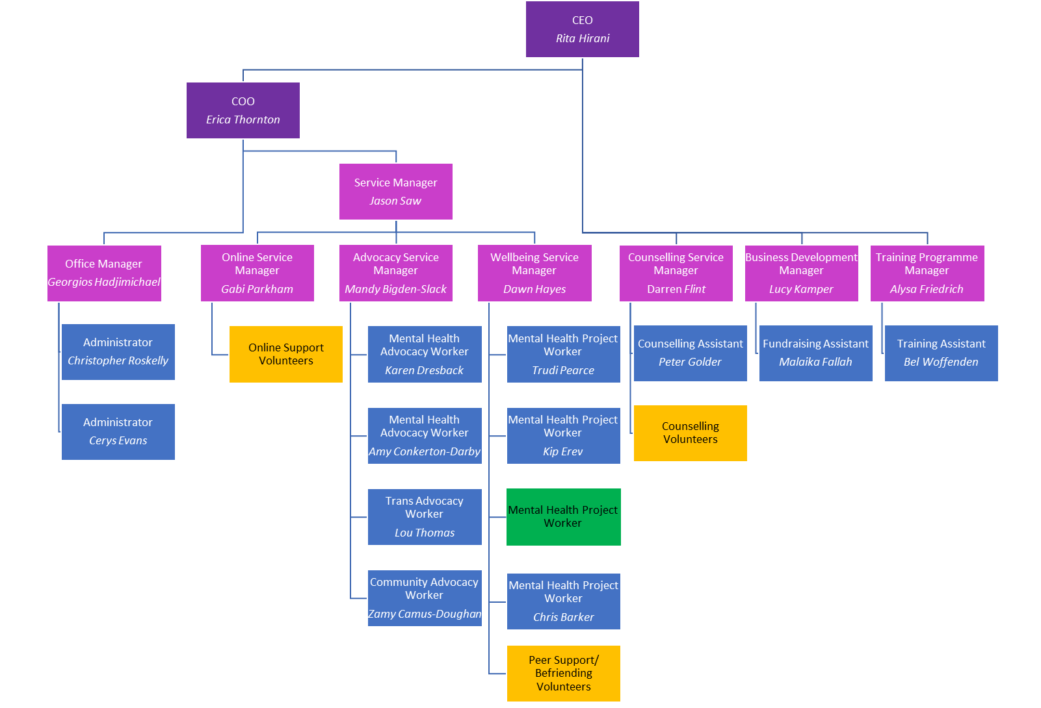

**Volunteer Teams**

Currently MindOut has approx. 50 volunteers working on the Counselling, Peer Mentoring, telephone befriending, online and group work services.

**Board of Trustees**

MindOut’s Executive Committee has 8 Trustees, led by our Chair, Simon Fillery.